1: Floyd’s
1 2 3 4 5
0 | 1 | ∞ | 1 | 5
9 | 0 | 3 | 2 | ∞
∞ | ∞ | 0 | 4 | ∞
∞ | ∞ | 2 | 0 | 3
3 | ∞ | ∞ | ∞ | 0
1
2
3
4
5
Step 1:
(2,1) = 9 (1,2) = 1 (2,2) = 0
(2,2) = min((2,2),(2,1)+(1,2)) = (0,10) = 0
(2,1) = 9 (1,4) = 1 (2,4) = (2,10) = 2
(2,1) = 9 (1,5) = 5 (2,5) = (∞,14) = 14
(5,1) = 3 (1,2) = 1 (5,2) = (∞,4) = 4
(5,1) = 3 (1,4) = 1 (5,4) = (∞,4) = 4
(5,1) = 3 (1,5) = 5 (5,5) = (0,∞) = 0
1 2 3 4 5
0 | 1 | ∞ | 1 | 5
9 | 0 | 3 | 2 | 14
∞ | ∞ | 0 | 4 | ∞
∞ | ∞ | 2 | 0 | 3
3 | 4 | ∞ | 4 | 0
1
2
3
4
5

Step 2 : (1,2) = 1 (2,1) = 9 (1,1) = (0,10) = 0
(1,2) = 1 (2,3) = 3 (1,3) = (∞,4) = 4
(1,2) = 1 (2,4) = 2 (1,4) = (1,3) = 1
(1,2) = 1 (2,5) = 14 (1,5) = (5,15) = 5
(5,2) = 4 (2,1) = 9 (5,1) = (3,13) = 3
(5,2) = 4 (2,3) = 3 (5,3) = (∞,7) = 7
(5,2) = 4 (2,4) = 2 (5,4) = (4,6) = 4
(5,2) = 4 (2,5) = 14 (5,5) = (0,18) = 0
Step 3: 1 2 3 4 5
0 | 1 | 4 | 1 | 5
9 | 0 | 3 | 2 | 14
∞ | ∞ | 0 | 4 | ∞
∞ | ∞ | 2 | 0 | 3
3 | 4 | 7 | 4 | 0
1
2
3
4
5

(1,3) = 4 (3,4) = 4 (1,4) = (1,8) = 1
(2,3) = 3 (3,4) = 4 (2,4) = (2,7) = 2
(4,3) = 2 (3,4) = 4 (4,4) = (0,6) = 0
(5,3) = 7 (3,4) = 4 (5,4) = (4,11) = 4
Step 4: 1 2 3 4 5
0 | 1 | 4 | 1 | 5
9 | 0 | 3 | 2 | 14
∞ | ∞ | 0 | 4 | ∞
∞ | ∞ | 2 | 0 | 3
3 | 4 | 7 | 4 | 0
1
2
3
4
5

(1,4) = 1 (4,3) = 2 (1,3) = (4,3) = 3
(1,4) = 1 (4,5) = 3 (1,5) = (5,4) = 4
(2,4) = 2 (4,3) = 2 (2,3) = (3,4) = 3
(2,4) = 2 (4,5) = 3 (2,5) = (14,5) = 5
(3,4) = 4 (4,3) = 2 (3,3) = (0,6) = 0
(3,4) = 4 (4,5) = 3 (3,5) = (∞,7) = 7
(5,4) = 4 (4,3) = 2 (5,3) = (7,6) = 6
(5,4) = 4 (4,5) = 3 (5,5) = (0,7) = 0

Step 5: 1 2 3 4 5
0 | 1 | 4 | 1 | 4
9 | 0 | 3 | 2 | 5
∞ | ∞ | 0 | 4 | 7
∞ | ∞ | 2 | 0 | 3
3 | 4 | 6 | 4 | 0
1
2
3
4
5

(1,5) = 4 (5,1) = 3 (1,1) = (0,7) = 0
(1,5) = 4 (5,2) = 4 (1,2) = (1,8) = 1
(1,5) = 4 (5,3) = 6 (1,3) = (3,10) = 3
(1,5) = 4 (5,4) = 4 (1,4) = (1,8) = 1
(2,5) = 5 (5,1) = 3 (2,1) = (9,8) = 8
(2,5) = 5 (5,2) = 4 (2,2) = (0,9) = 0
(2,5) = 5 (5,3) = 6 (2,3) = (3,11) = 3
(2,5) = 5 (5,4) = 4 (2,4) = (2,9) = 2
(3,5) = 7 (5,1) = 3 (3,1) = (∞,10) = 10
(3,5) = 7 (5,2) = 4 (3,2) = (∞,11) = 11
(3,5) = 7 (5,3) = 6 (3,3) = (0,10) = 10
(3,5) = 7 (5,4) = 4 (3,4) = (4,11) = 4
(4,5) = 3 (5,1) = 3 (4,1) = (∞,6) = 6
(4,5) = 3 (5,2) = 4 (4,2) = (∞,7) = 7
(4,5) = 3 (5,3) = 6 (4,3) = (2,9) = 2
(4,5) = 3 (5,4) = 4 (4,4) = (0,7) = 0
0 | 1 | 4 | 1 | 4
8 | 0 | 3 | 2 | 5
10 | 11 | 0 | 4 | 7
6 | 7 | 2 | 0 | 3
3 | 4 | 6 | 4 | 0

2
Item | Weight | Value
1 | 2 | 12
2 | 1 | 10
3 | 3 | 20
4 | 2 | 15

 | 0 | 1 | 2 | 3 | 4 | 5
0 | 0 | 0 | 0 | 0 | 0 | 0
1 | 0 | 12 | 12 | 12 | 12 | 12
2 | 0 | 12 | 12 | 22 | 22 | 22
3 | 0 | 22 | 22 | 22 | 22 | 32
4 | 0 | 32 | 32 | 32 | 32 | 37

i | j | V[i, j] | V[i,j]= Max(v[i-1,j],v[i-1,j-w[i]]+p[i])
4  3  3  2  2  1  1  1  1  2 | 5  5  3  5  2  5  4  2  1  3 | V[4,5]  V[3,5]  V[3,3]  V[2,5]  V[2,2]  V[1,5]  V[1,4]  V[1,2]  V[1,1]  V[2,3] | V[4,5]= Max(v[3,5],v[3,3]+15)= 37  V[3,5] = Max(v[2,5],v[2,2]+20)= 32  V[3,3] = Max(v[2,3],v[2,0]+20)=22  V[2,5] = Max(v[1,5],v[1,4]+10)=22  V[2,2] = Max(v[1,2],v[1,1]+10)=12  V[1,5] = Max(v[0,5],v[0,3]+12)=12  V[1,4] = Max(v[0,4],v[0,2]+12)=12  V[1,2] = Max(v[0,2],v[0,0]+12)=12  V[1,1] = 0  V[2,3] = Max(v[1,3],v[1,2]+10)=22

3. Single Source Shortest Path(DJ)
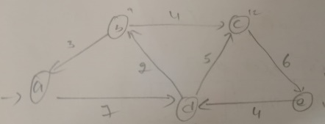

a b c d e
0 | ∞ | ∞ | 7 | ∞
3 | 0 | 4 | ∞ | ∞
∞ | ∞ | 0 | ∞ | 6
∞ | 2 | 5 | 0 | ∞
∞ | ∞ | ∞ | 4 | 0
0 | 0
∞ | 9
∞ | 12
7 | 7
∞ | ∞
a d[a]
b d[b]
c d[c]
d d[d]
e d[e]

s | V=V-s | d[v]=min(d[v],d[u]+cost[u][v] | v$∈$V-s
a | - | --- | d
a,d | b,c,e | d[b]=min(d[b],d[d]+cost[d,b])=( ∞,7+2)=9  d[c]=min(d[c],d[d]+cost[d,c])=( ∞,7+5)=12  d[e]=min(d[e],d[d]+cost[d,e])=( ∞,7+∞)=∞ | b
a,d,b | c,e | d[c]=min(d[c],d[b]+cost[b,c])=(12,9+4)=12  d[e]=min(d[e],d[b]+cost[b,e])=( ∞,9+∞)=∞ | c
a,d,b,c | e | d[e]=min(d[e],d[c]+cost[c,e])=( ∞,12+6)=18 | e

d[a] d[b] d[c] d[d] d[e]
0 | 9 | 12 | 7 | 18

4 . Kruskal’s
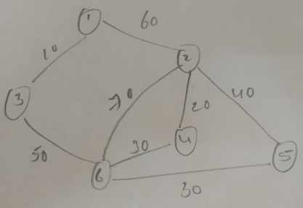

1-3 10
2-4 20
4-6 30
5-6 30
2-5 40
3-6 50
1-2 60
2-6 70
Steps | Deleted Edge  (u,v) | i=find(u)  j=find(v) | o/p  (u,v) | Union(i,j)  S[1],s[2],s[3],s[4],s[5],s[6]
Initial  1  2  3  4  5  6  7  8 | -  1-3  2-4  4-6  5-6  2-5  3-6  1-2  2-6 | -  1,3  2,4  2,6  5,2  2,2  1,2  1,1  1,1 | -  1-3  2-4  4-6  5-6  Discard  3-6  Discard  Discard | 1 2 3 4 5 6  1 2 1 4 5 6  1 2 1 2 5 6  1 2 1 2 5 2  1 2 1 2 2 2  1 2 1 2 2 2  1 1 1 2 2 2  1 1 1 2 2 2  1 1 1 2 2 2

10+50+30+30+20 = 140
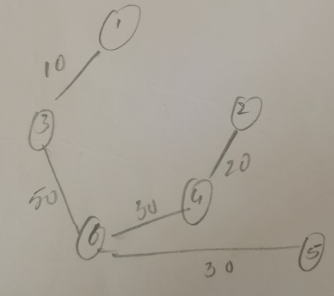
5. A: 22 B: 13 C: 18 D: 16 E: 31
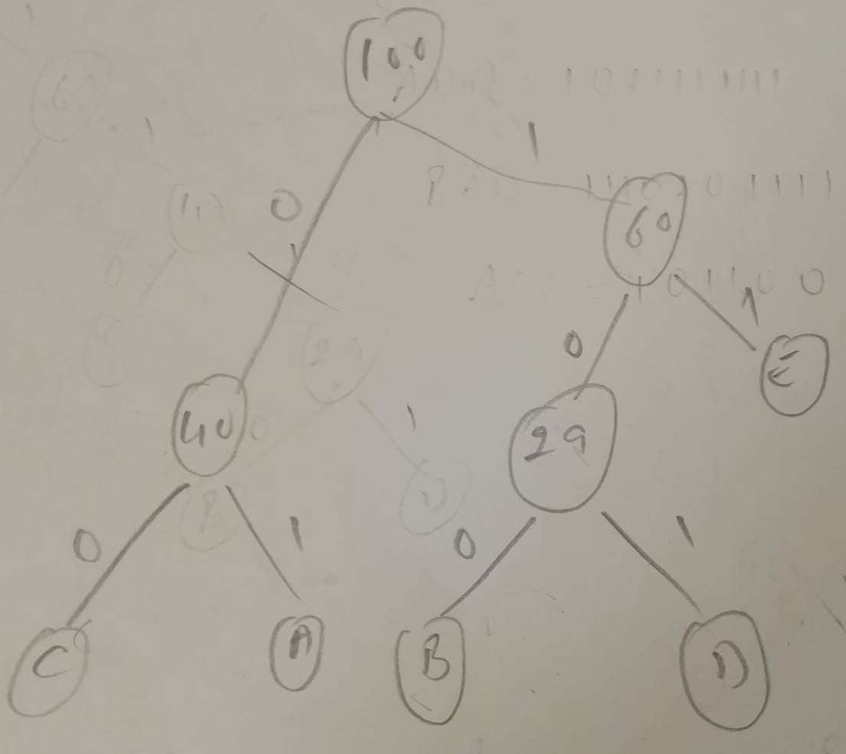
C A B = 0001100
ADD = 01101101
BAD = 10001101
ACE = 010011
110011 = ECE
1000110001 = BABA
6. Prim’s
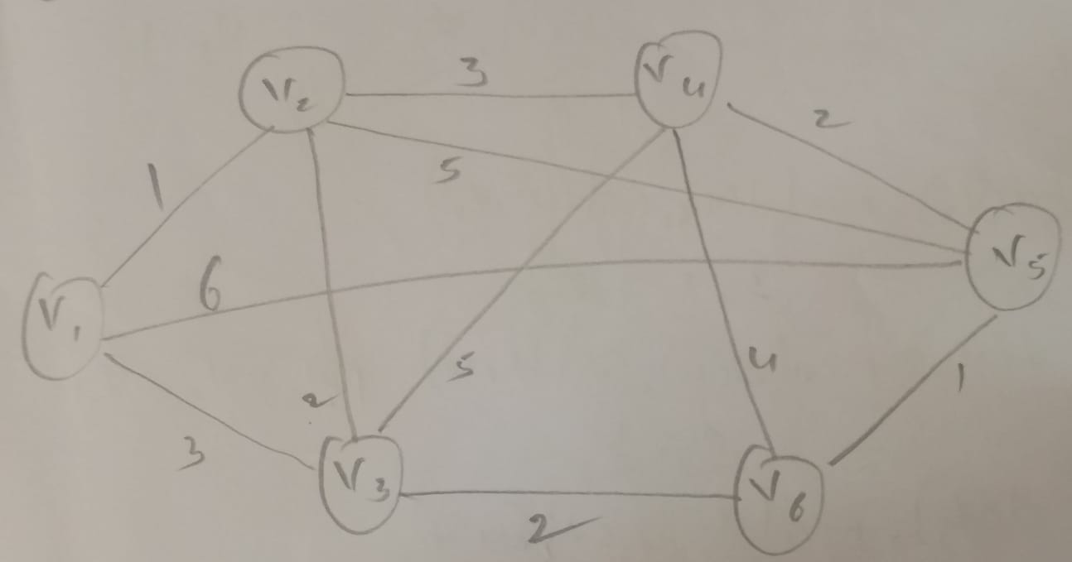

v1 v2 v3 v4 v5 v6
0 | 1 | 3 | ∞ | 6 | ∞
1 | 0 | 2 | 3 | 5 | ∞
3 | 2 | 0 | 5 | ∞ | 2
∞ | 3 | 5 | 0 | 2 | 4
6 | 5 | ∞ | 2 | 0 | 1
∞ | ∞ | 2 | 4 | 1 | 0
v1
v2
v3
v4
v5
v6
d[v1] d[v2] d[v3] d[v4] d[v5] d[v6]
0 | 1 | 3 | ∞ | 6 | ∞

p[v1] p[v2] p[v3] p[v4] p[v5] p[v6]
0 | V1 | V2 | V5 | V6 | V3

s | v=V-s | d[v]=min(d[v],cost[u][v]) | P[v]=u | Find  u,d[u] | o/p  u,p[u]
v1 | v2,v3,v4,v5,v6 | -- | - | v2,1 | v2,v1
v1,v2 | v3,v4,v5,v6 | d[v3]=min(d[v3],cost[v2,v3])=(3,2)=2  d[v4]=min(d[v4],cost[v2,v4])=(∞,3)=3  d[v5]=min(d[v5],cost[v2,v5])=(6,5)=5  d[v6]=min(d[v6],cost[v2,v6])=(∞,∞)=∞ | p[v3]=v2 | v3,2 | v3,v2
v1,v2,v3 | v4,v5,v6 | d[v4]=min(d[v4],cost[v3,v4])=(∞,5)=5  d[v5]=min(d[v5],cost[v3,v5])=(6,∞)=6  d[v6]=min(d[v6],cost[v23v6])=(∞,2)=2 | p[v6]=v3 | v6,2 | v6,v3
v1,v2,v3,v6 | v4,v5 | d[v4]=min(d[v4],cost[v6,v4])=(∞,4)=4  d[v5]=min(d[v5],cost[v6,v5])=(6,1)=1 | p[v5]=v6 | v5,1 | v5,v6
v1,v2,v3,v6,v5 | v4 | d[v4]=min(d[v4],cost[v5,v4])=2 | p[v4]

1+2+2+2+1=8
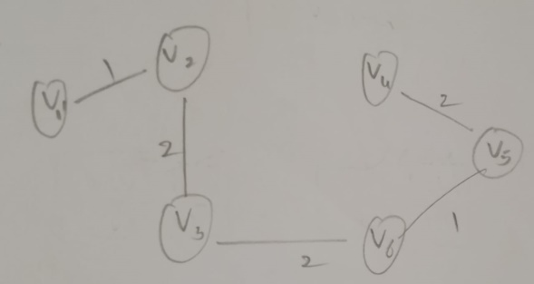

Using Branch and Bound technique solve the below instance of knapsack problem.
Item | Weight | Value
1 | 2 | 12
2 | 1 | 10
3 | 3 | 20
4 | 2 | 5

Sol:
Item | Weight | Value | Vi+1/Wi+1
1 | 1 | 10 | 10 v1/w1
2 | 2 | 12 | 6 v2/w2
3 | 3 | 20 | 6 v3/w3
4 | 2 | 5 | 2 v4/w4

M=5
Step: 1 i=0 w=0 v=0 v1/w1=10
M-w = 5-0 = 5 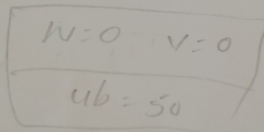
ub = 0+5*10 = 50

Step: 2 I = 1 v2/w2 = 6
With item 1 Without Item 1
W = weight item 1 + w = 1+0 =1 w = 0+0=0
V= v+v1 = 0+10 = 10 v= 0+0 = 0
M-w =5-1 =4 M-w=5-0=5
ub = 10+4*6=34 ub=0+5*6= 30

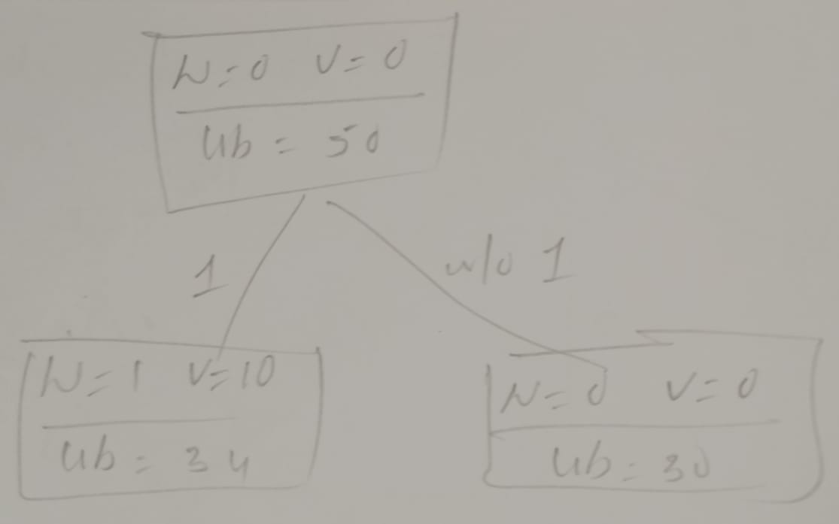
Step 3
Item 2 v3/w3 = 6
With item 2 Without Item 2
W = weight item 2 + w = 2+1 = 3 w = 0+1=1
V= v+21 = 10+12 = 22 v= 10+0 = 10
M-w =5-3 =2 M-w=5-1=4
ub = 22+2*6=34 ub=10+6*4= 34
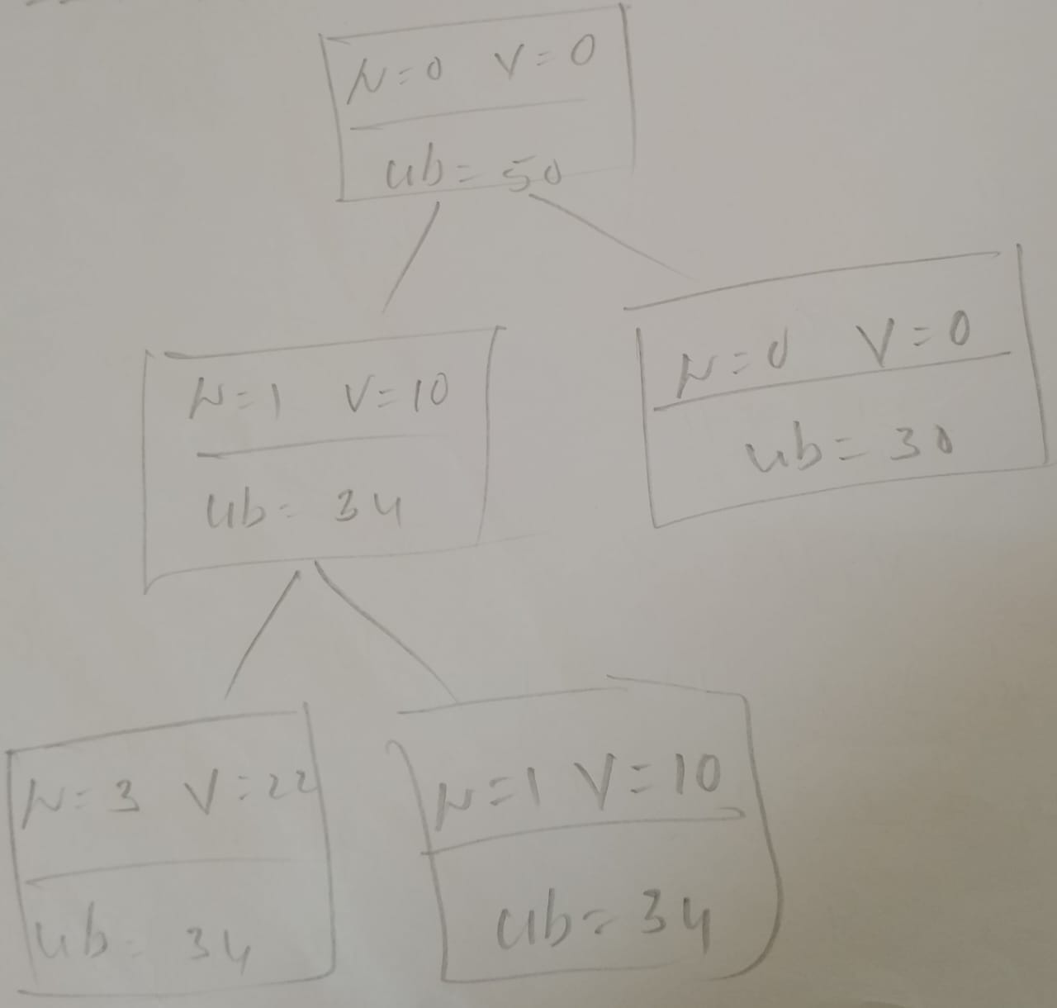
Step 4
Item 3 v4/w4 = 2
With item 3 Without Item 3
W = weight item 2 + w =3+3 = 6 w = 0+3=3
Not Feasible v= 0+22 = 22
M-w=5-3=2
ub=22+2*2= 26
Step 5
Item 4 v5/w5 = ?
With item 4 Without Item 4
W = weight item 4 + w = 2+3 = 5 w = 0+w=0+3=1
V= v+21 = 22+5 = 27 v= 22+0 = 22
ub = v ub = 27 ub=v ub=22

